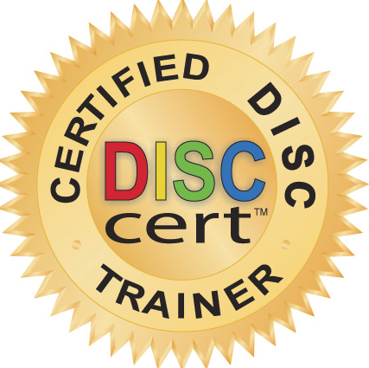

Participants __Department or Division or List Type of Participants...
e.g. Employees Eager to Learn ho to communicate better

Objectives Participants will be energized as they learn how to...
-Understand their own Behavior Communication Style; strengths and tendencies. .
-Identify someone else's style by quick, user-friendly techniques.
-Adjust their behavior to increase communication effectiveness with all levels

Features
Highly interactive, fun-practical activities
User-friendly assessment & automated weekly DISC Tips for simple reinforcement.

Overview – Quick Pre-work
Complete Online DISC Assessment (Takes 10 minutes. Generates a 36 Page Report)
Complete Report/Workbook Page 8 (Takes 7 minutes.)

Overview – 4 Hour Session
What is DISC Model & Styles? Dominant, Influence, Steady, Conscientious
Insight on How to Identify Styles (Movie Clips for Examples)
Practical Learning Activities to emphasize Value of Understanding Styles
Experience How Important it Is to Adapt to Other Styles
Gain Strategies for Effectively Communicating with Other Styles
Skill Practice using new Communications Strategies at Work; e.g. Emails, Meetings
Explore how to Apply DISC in all Work Communications
Develop Practical Action Plans

Proposed Training Date _____

Program Fees
4 Hour Training $3,000
DISC Assessments* @ $85 ea X $
Total $

Optional:
30 Min Phone Coaching Call @ $100 x $
Total $

Fee Schedule 50% deposit upon date confirmation & balance due upon completion.
*If additional participants are added to the original count, their DISC Assessment cost is to be added to balance due.

Printed Name _______________________________ Date __________

Signature Acceptance __________________________

Communicate for Success
With DISC (put your own title)

Partial Clientele List
Private Industry
*
*
*
Non-Profits
*
*
Academic
*
*

Trainer’s Credentials
* DISC Certified Trainer
*
*

Your Photo Here

Your Name & Company
Your Area of Expertise
How many years Training Expert

Your Logo Here

Phone
Website
Email

