**DISC Training Materials**

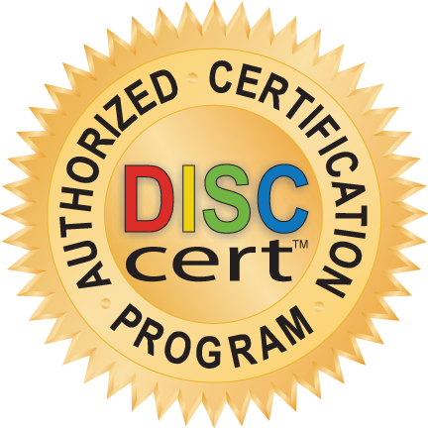

***Welcome…. DISC Certified Grads!***

**What is in the “DISC Training Materials”?**

Over the years, so many of you Grads have shared with me your impressive DISC Training Materials; *Handouts, PPTS, Learning Activities*. In addition, you have contributed some wonderfully practical approaches to *Implementing DISC Training* as well as how to *Follow*-*Up and Reinforce DISC* in your organizations.

The **DISC Training Materials**, are the compiled wisdom and experience of your DISC Grad Community. It is a continually growing collection of FREE DISC Resources, and in most cases with an option for you to customize for your organization’s needs . Dates are included for each document (for easier reference.) I do ask, where you see one of your fellow DISCcert Grads mentioned as the author, please give them the well-deserved acknowledgement they are due in the DISC Materials you use.

YOU and YOUR DISC Training, DISC Coaching are truly touching the lives with the simple, yet so powerful DISC Practices. **YOU** are bringing hope, energy and practical DISC teachings that inspire people to be ALL they can be.

And below are just a few images to show you what FREE DISC Training Resources await you. To locate, see Folder Reference.)

*With much appreciation and admiration,*

*Bonnie*

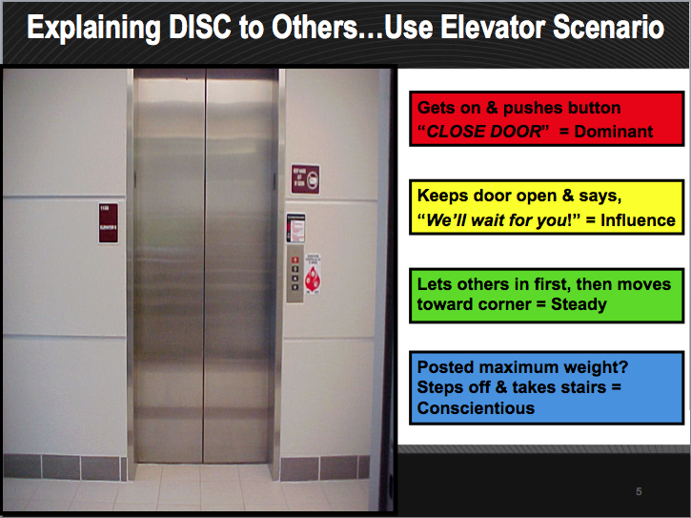 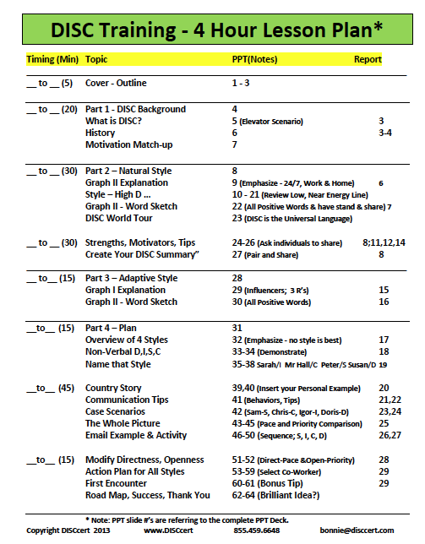 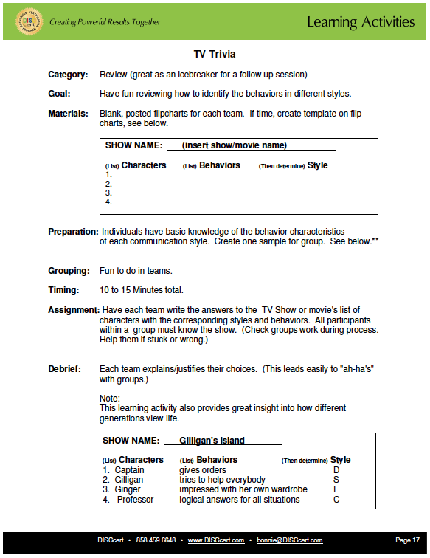 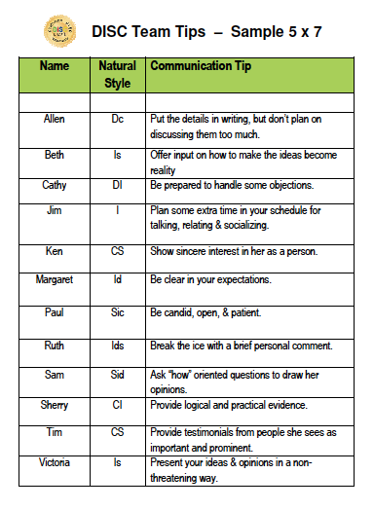

(PPT Folder) (Lesson Plan Folder) (Learning Activities Folder) (Follow-up Folder)