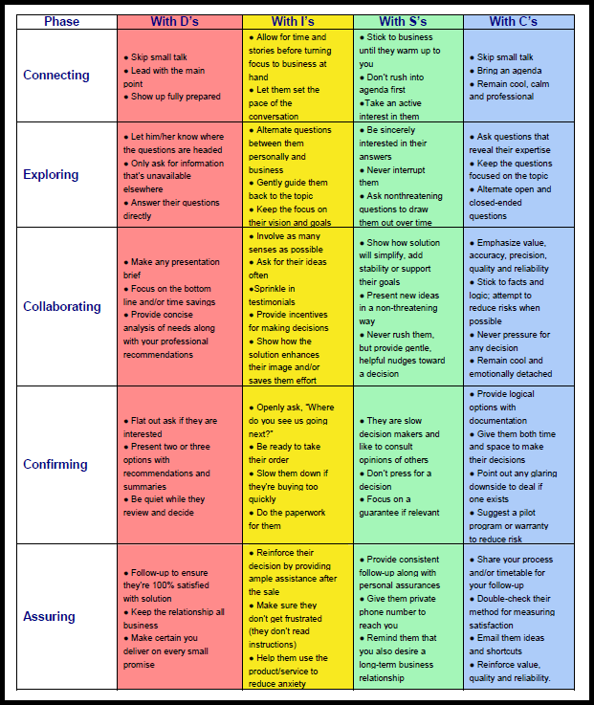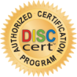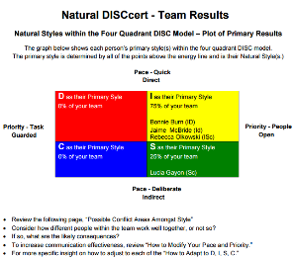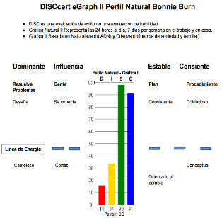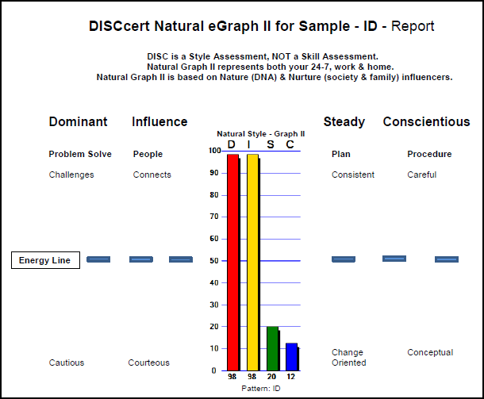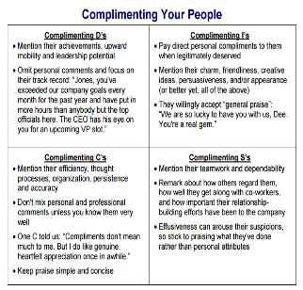

Sales will increase!

* Steps in sales process match up with D, I, S, C Prospects

**DISC Sales**

10-2016

People create win-win communications

* Online, user-friendly assessment
* 35 page, personalized report
* Success strategies & learning activities

DISC is the universal communication model used to explain the 4 core behavior styles:

**D**ominant, **I**nfluence, **S**teady, **C**onscientious

**DISC Spanish**

**DISC Team**

DISC **=** Communication Success

**DISC Self Report**

Leaders become more effective

* Ten leadership competencies match up with DISC styles
* i.e. Motivating your people, Giving constructive feedback

**DISC Leadership**

Builds stronger teams

* Provides overview of team member styles
* Great for new teams or

for resolving conflicts

Assessment & report available in Spanish

* Includes same content as

English version

People create win-win communications

* Online, user-friendly assessment
* 35 page, personalized report
* Success strategies & learning activities